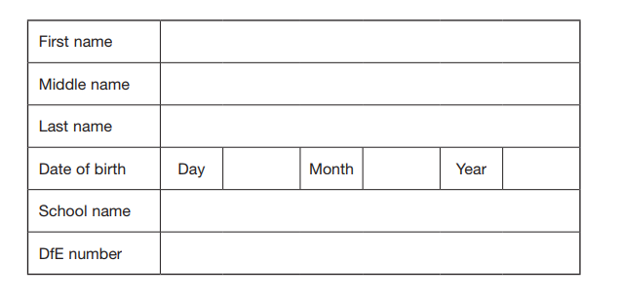
Fractions, Decimals and Percentages.

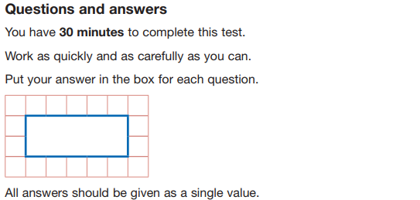
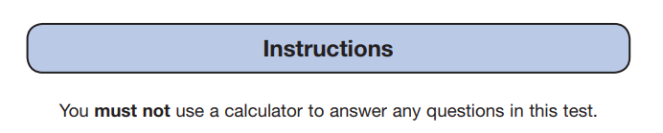
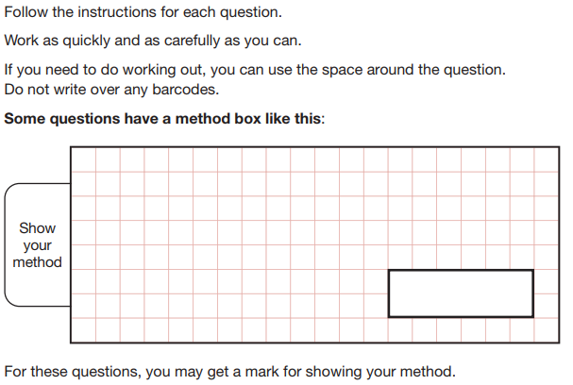

Fill in the missing values as either a percentage , a decimal or fractions.
0.2

5/100

100%

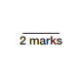

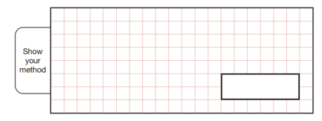
Charlotte’s favourite clothes shop has a sale. The dress originally costs £16 and the shoes were priced at £56.50p. When she went to pay and there was 50% of the shoes. How much did she end up paying for both items together?

Circle the calculation which gives the smallest answer.
¼ of 100 75% of 80 50% of 60 3/5 of 25 25% of 40

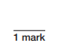

Tick all the correct statements.
6/10 = 0.65
½ = 0.2
0.05 > 0.5
0.01 < 0.1
3/5 = 0.6
0.25 > 0.2
How do you work out 75% of an amount?

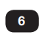
What is 35% of 6592ml?

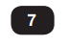
Cars were parked in a field. 25% were blue , 0.45 were orange and 17/100 were yellow. How many cars were parked in the field? Give your answer as a fraction.

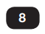
Tick the box that best matches the definition an equivalent fraction.

When two fractions are exactly the same.

When numerator is bigger than the denominator.

When there is a whole number and a fraction together.

When you a fraction has all the same digits.

What is 20% of £8525

George thinks that 0.8 is smaller than 4/5. Explain why George is incorrect.

