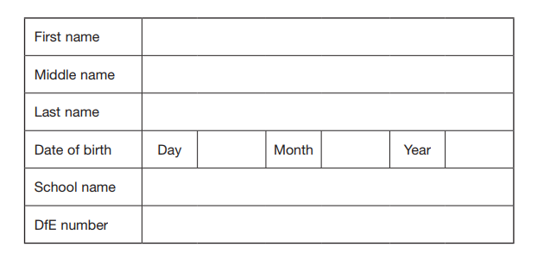
Multiplication and Division Vocabulary

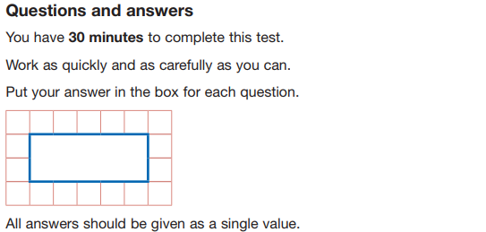
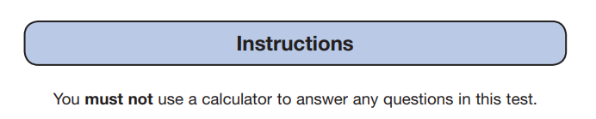
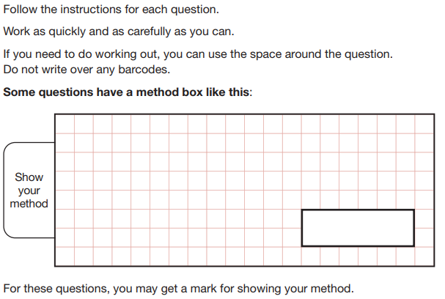

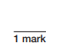
What is a factor?

What are the factor of 18?

Which of these numbers is a common factor of 18 and 24? Circle the correct answer.

4 5 6 8 9

What is a prime number?

Which of the following lists of numbers would go into the empty box in this sorting diagram? Circle the correct answer.
 | Prime | Not Prime
Even | 2 | 4,10 , 12 ,28
Odd | 7, 11, 13, 19

- 3 ,5 ,9 ,11 C) 3 , 11 , 27 , 31
- 5 ,8 ,12 ,14 D) 9 , 15 , 21 , 33

What is the sum between all the prime number between 1 and 10?

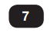
Tick the box that best matches the definition for what a multiple is.

Multiples of two numbers that are the same.

A number in another number’s times table.

A number that divides exactly into another number.

A number with more than two factors.
Which number is in the wrong place in the Venn diagram? Circle the number which is in the wrong place and then re write it in the correct place.
63
7
Even Number
Multiples of 7

267
647
28
8
147
217
127
357
407

Amy is 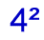 years old and her grandma is years old.
What is the difference between their ages?
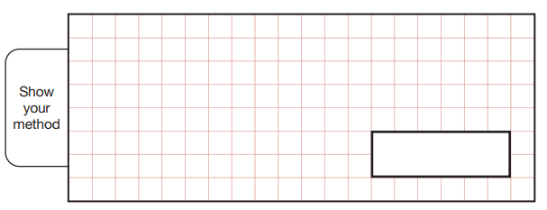
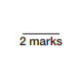
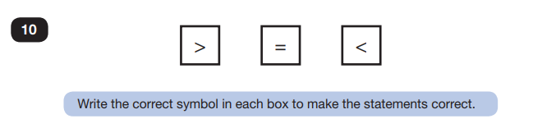

Put a number less than 30 in each box to make the statement correct.
Square Number
Square Number
Prime number
Square Number
=
+

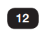
Ellie thinks that 9 is a composite number.

Prove whether she is correct or incorrect

